Thomas Chung

Pantoja

COEN 171

4 February 2016

HW 2

Part I

\*Note on Part I: I have improved the game so that there is an actual challenge. You must dodge the bubbles in order to survive. The longer you survive, the better your score.

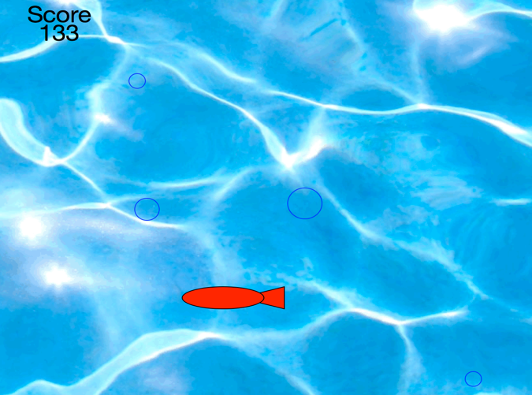

Part II

1. Python is both an interpreted language and a compiled language. Compiled in the sense that many of its functions were compiled before its interpreted. Being interpreted and compiled is up to the implementation. There are multiple implementation of Python.
2. I consider Python an imperative language. An imperative language uses a sequence of statements to reach a goal. That’s what Python does.
3. Yes, you can declare global variables in Python.
4. Parameters are passed to functions like they would in C++ and Java. You can pass in parameters via the () operator of functions.
5. For-loop syntax in Python are given as: “for” variable “in” Object. An Object can be a list or a class in Python.
6. If the question is asking if Python is flexible, Python is flexible in the sense that there are many ways to implement design ideas. However, the syntax of Python is extremely rigid and everything has to be indented correctly. So in that way, Python is inflexible. In exchange, Python won’t execute any unexpected statement.
7. Compare to C++, Python is 10-100 times slower.